# Chapter 3: Design

In this Chapter, I will introduce the DetailedClass Diagram, Sequence Diagrams and UI prototype of my Ao Neko Website.

3.1 Detailed Class Diagram

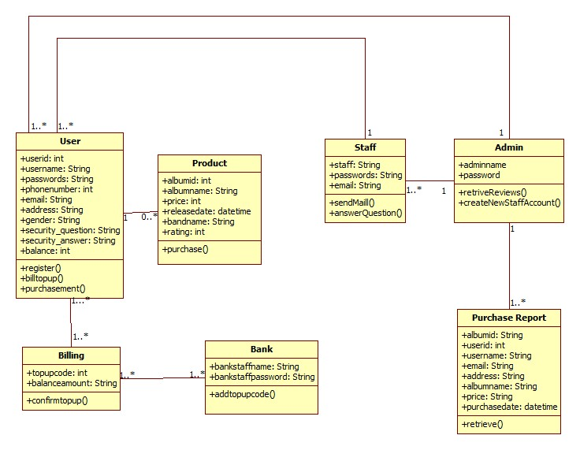

3.2 Sequence Diagram for User Registration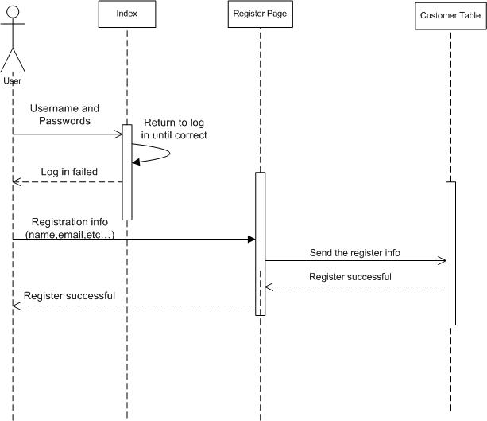

**3.3 Sequence Diagram for User Purchasing Album**

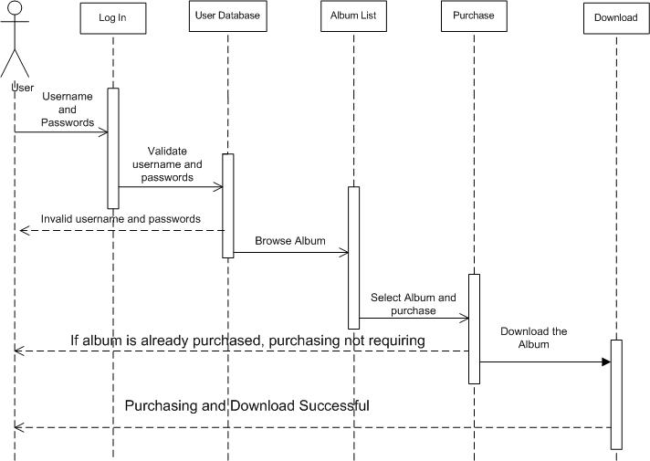

**3.3 Sequence Diagram for Bank Staff adding top up bills**

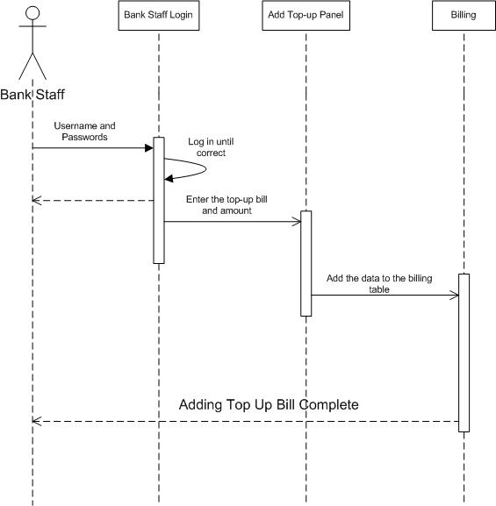

**3.5 Sequence Diagram for Staff Panel**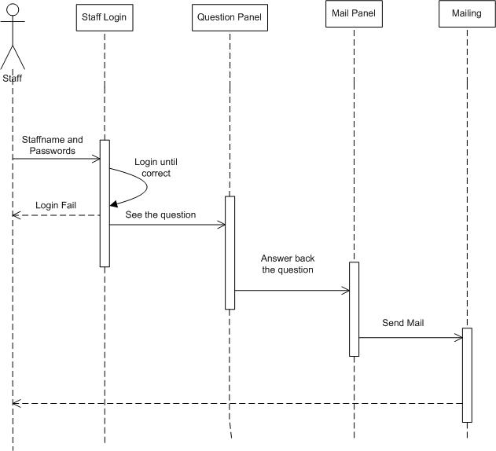

**3.6 UI Prototype for Ao Neko Webpage**

**Home Page**

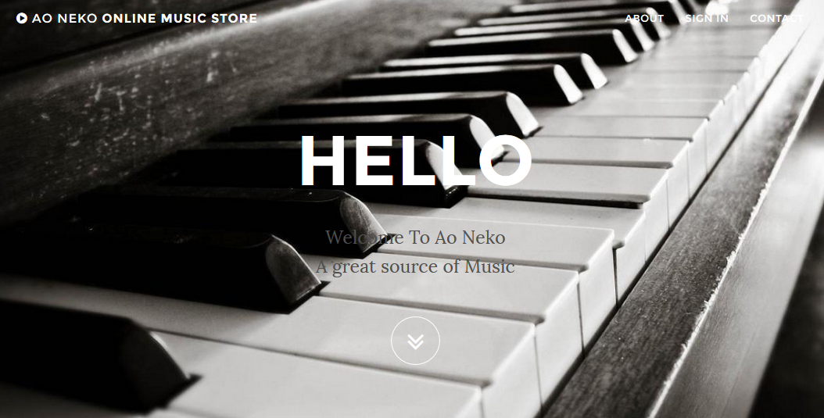

**Register Page**

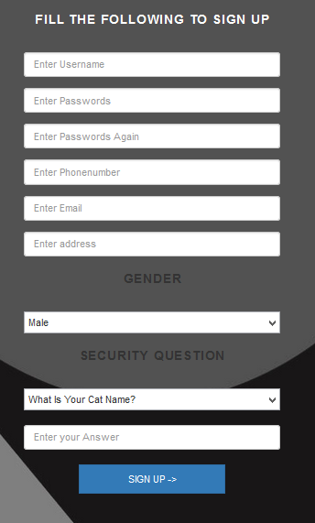

**Sign In Modal**

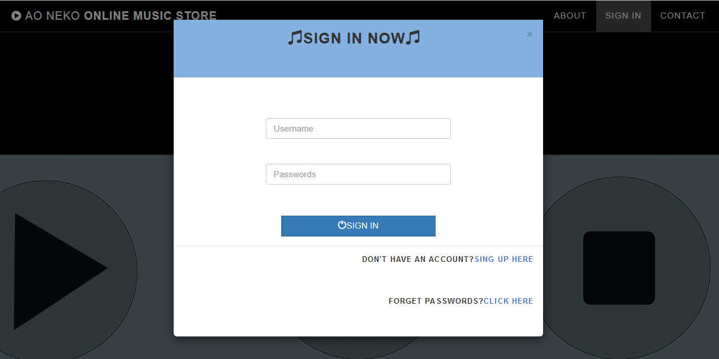

**Sign In Page**

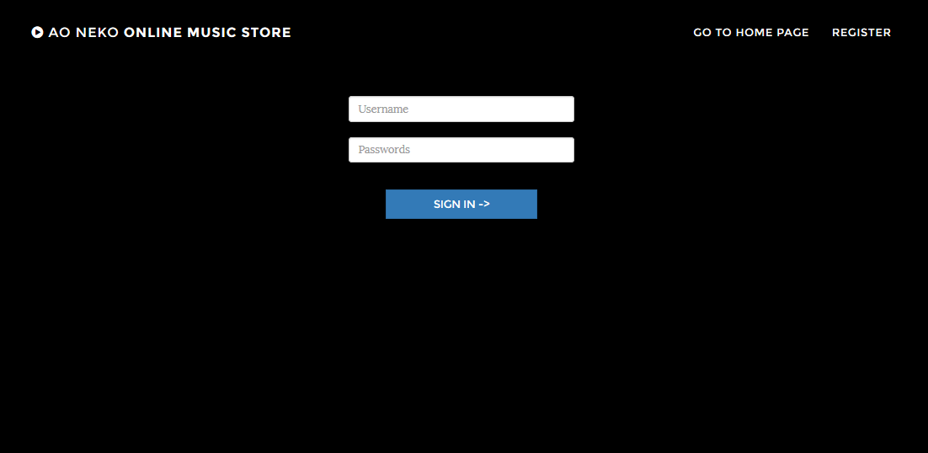

**Map API**

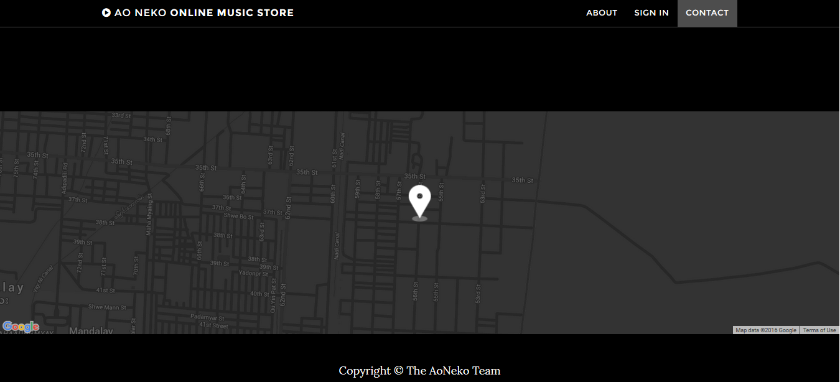

Conclusion

In this chapter, I described about the detailed class diagram, sequence diagram and some of my webpage’s user interface.